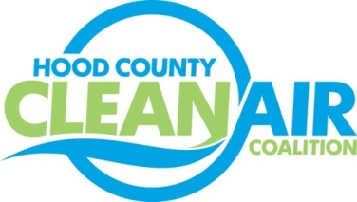
Meeting: Tuesday, October 6, 2015
Neely House
304 East Rucker Street, Granbury, Texas 76048
8:30-10:00 a.m.

Agenda

- Call Meeting to Order
- EPA Updates – Carrie Paige
- Regional Updates – Michelle McKenzie
  - Air Quality Funding Opportunities for Vehicles
  - Regional Air Quality Status
  - Revised Ozone Standard to be Announced October 1, 2015
  - Air Quality Technical Meeting
  - Ozone Advance Conference Call
- Local Updates – Michelle McKenzie
  - Review of September Meeting Summary
  - Review of Projects
    - Monthly Budget Review for August
    - Status of Projects
      - Surrey Bikes
      - Propane Refueling Stations
      - TV Programming
      - Additional Radio Advertising
    - HCCAC Bank Account
    - FY 16/17 PGA
      - Status of PGA
      - RFQ Requirements
      - Future Events to Consider for Participation
  - Reports
    - Ozone Update through September
    - EPA webinar on Proposed Oil and Gas Rules
    - Air North Texas Meeting
5.) Discussion
6.) Adjourn

